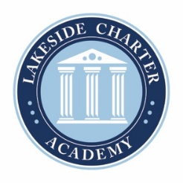

Board of Directors Meeting Agenda
November 29, 2023
Location: Zoom 12:00pm
Lakeside Charter Board Meeting
Password: LCABoard

- Call to Order
- Reading of Mission Statement: Lakeside Charter Academy, in partnership with parents, will cultivate engaged learners through scholarship, leadership, and citizenship
- Reading of Conflict of Interest Statement
- Approval of October 27, 2023 Minutes*
- Public Comments
- Election of Board Officers
- Audit Report- Jay Sharpe
- Mike Morley-ACD
- Principal Report
  - Enrollment Update
  - Staffing*
  - Parent Notification Law
  - Renewal
- Business Manager Report
  - October Budgets Reports
  - Retaining Wall update
  - Heat/Air System update
  - Board applications
- Closed Session: Pursuant § 143-318.11 section 5 that is relation to discussing a lease and personnel.
- Adjourn*

* Requires Board Action

