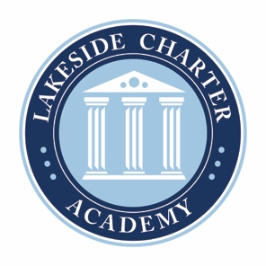
Lakeside Charter Academy, in partnership with parents, will cultivate engaged learners through scholarship, leadership, and citizenship
Agenda: Lakeside Charter Academy
Regular Meeting
Board of Directors Meeting

Location: Main Campus
January 23, 2020 | 7:00PM

- Call to Order
- Reading of Conflict of Interest Statement
- Approval of October 24, 2019 Minutes
- Reports – Principal report, handbooks and policy changes, enrollment/marketing, activities/Friday Forums, surveys, PAT, etc.
- Finance – Business manager
  - Review Statements
  - Grant
  - Loan ratification* and funding update
  - Fundraising
  - Staffing approval and updates*
- Adjourn

* Requires Board Action

