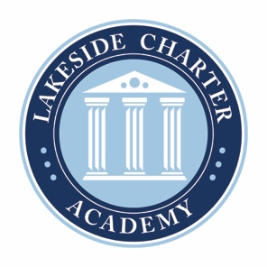
Lakeside Charter Academy, in partnership with parents, will cultivate engaged learners through scholarship, leadership, and citizenship
Agenda: Lakeside Charter Academy
Regular Meeting
Board of Directors Meeting

Location: Conference Call
March 26, 2020 | 7:00PM EST

- Call to Order
- Reading of Conflict of Interest Statement
- Approval of February 27, 2020 Minutes
- Reports – Principal report, handbooks and policy changes, enrollment/marketing, activities/Friday Forums, parent surveys, PAT, etc.
- Finance – Business manager
  - Review Statements
  - Insurance - update
  - Letter of Credit – Any further update?
  - Grant
  - Fundraising
  - Facility update
  - Telecommuting policy*
  - Check Signing Policy*
  - Audit contract approval – Jay Sharpe*
  - Staffing approval and updates*
- Adjourn

* Requires Board Action

