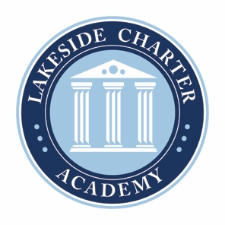
Lakeside Charter Academy, in partnership with parents, will cultivate engaged learners through scholarship, leadership, and citizenship
Agenda: Lakeside Charter Academy
February 24, 2022
Regular Meeting
Board of Directors Meeting

Location: Conference Call
202.926.1041; 555810

February 24, 2022, | 4PM EST

- Call to Order
- Reading of Conflict of Interest Statement
- Approval of January 27 Minutes*
- Reports – Principal report, Marketing, enrollment update, Charter School Capital,
  - Mask Policy*
- Business Manager
  - Renewal Update
  - Amended Budget*
  - Board Elections discussions
  - Board Committees discussions
  - Board nominations policy*
  - Resignations/Terminations*

- Adjourn

* Requires Board Action

