Adding a Student to an Existing MyPaymentsPlus Account

Step 1: Visit www.mypaymentsplus.com and Sign In.
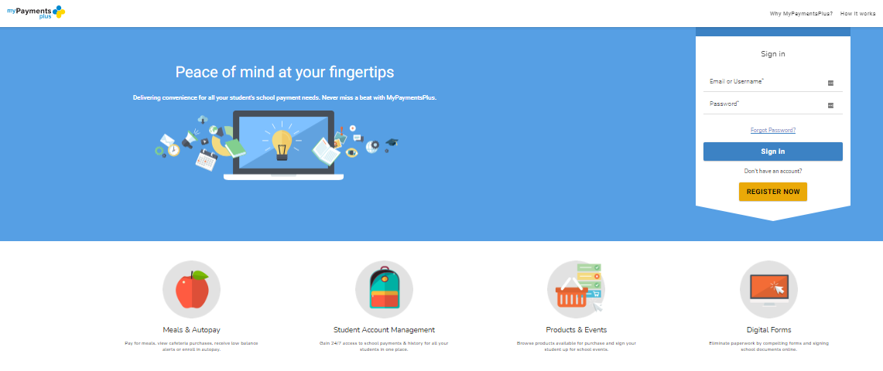

Step 2: On the Dashboard you will then Click “My Account” > “Manage Accounts” then click
“Add Account” to add student.

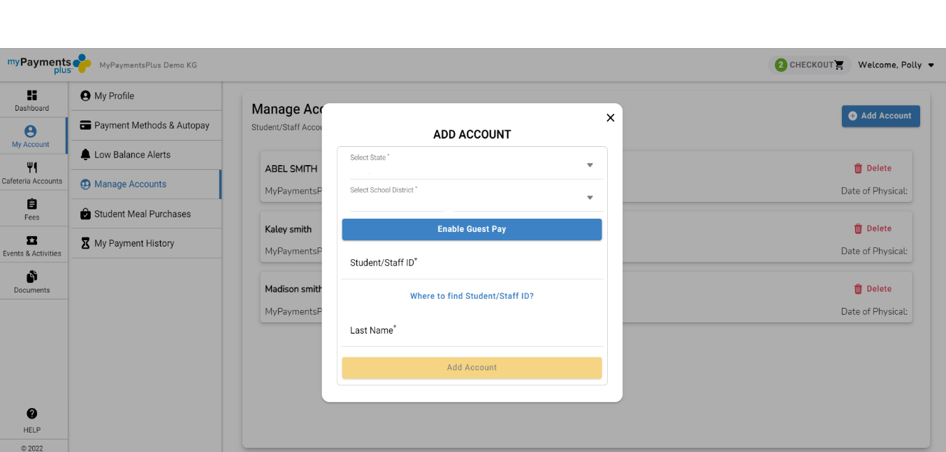
Step 3: Using their ID number and last name, add student(s) to your account and click Done.

Step 4: If you need to remove a student from your account you can click the “Delete” option on the right. This will remove student from your account.

