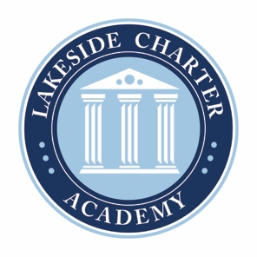
Lakeside Charter Academy, in partnership with parents, will cultivate engaged learners through scholarship, leadership, and citizenship
Agenda: Lakeside Charter Academy
March 24, 2022
Regular Meeting
Board of Directors Meeting

Location: Conference Call
202.926.1041; 555810

March 24, 2022, | 12PM EST

- Call to Order
- Reading of Conflict of Interest Statement
- Approval of February 24 Minutes*
- Reports – Principal report, Marketing, enrollment update, Knight’s Game, Bus Driver, Summer Program*
- Business Manager
  - February Budget Update
  - Board Elections discussions
  - Board Committees discussions
  - Schools 990*
  - Terminations*

- Adjourn

* Requires Board Action

